## Configuring Sling Resource Resolution in Felix Console (Resource Mapping configuration )

Resource Mapping is done to define redirects, vanity urls.

In WEM, all resource having ***/content/*** will be replaced by ***/c/.*** For eg : cpdm homepage

***/content/r/techguidance/index.html*** can be accessed as ***/c/r/techguidance/index.html*** owing to below configuration

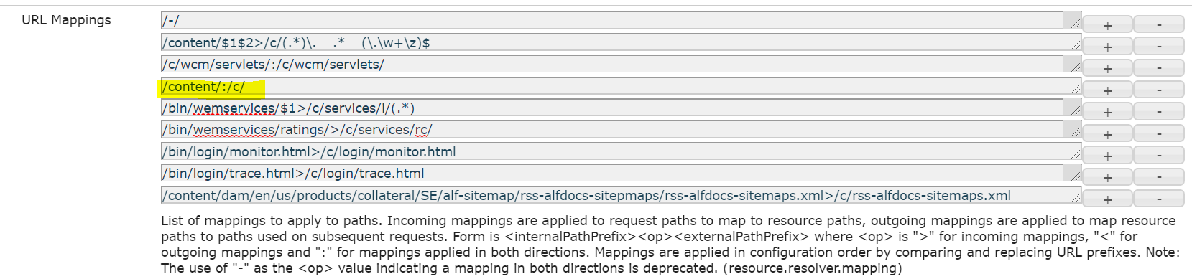

* Apache Sling Resource Resolver Factor (org.apache.sling.jcr.resource.internal.JcrResourceResolverFactoryImpl). This is access at felix console and required configuration can be altered aligning to our requirement

|  |  |
| --- | --- |
| Property | description |
| Resource Search Path -Multivalued - evaluated from top to bottom | When resources are given relative path, the values given here are prefixed and then searched in jcr.  Eg: first resource is looked up in /apps and then in /libs |
| Namespace Mangling - boolean | This feature is to replace *'jcr:content'* to *'_jcr_content'.* URI with : in the path is valid but to be on the safer side with systems which cant cope up with : in URI |
| URL Mappings | Has properites in the <internalPathPrefix><op><externalPathPrefix>  Key value pairs to resolve the request path to real path in repository and vice versa which depends on the <op>     |  |  | | --- | --- | | <op> |  | | < | outgoing mappings | | > | Incoming mappings | | : | Both direction mapping | | - | Both directions deprecated | |

The mappings can be done at felix console as well as from CRXDe as well.

<http://localhost:4502/crx/de/index.jsp#/etc/map/http>

here we can

1. Create a node of type *sling:Mapping*
2. create a property *sling:match(String) –* provide a string value to match against
3. create a property *sling:internalRedirect(String) –* another string to which the request has to be redirected to

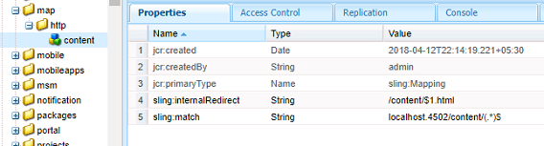

Resource mappings specific to run modes can also be done at /etc/map.<runmode>

1. create a *sling:OsgiConfig* node by name org.apache.sling.jcr.resource.internal.JcrResourceResolverFactoryImpl under /apps/sytem/config.<runmode>(Sling:Folder)
2. provide required properties same as **Apache Sling Resource Resolver Factory** in configMgr.
3. Point the property *Mapping Location* to ‘/etc/map.<runmode>’
4. Give properties as above screen shot for redirects as required

Useful Links:

<http://aemtips.blogspot.com/2013/05/how-to-configure-custom-mappings-based.html>

<http://aemcases.blogspot.com/2018/04/url-mapping-and-removing-html-extension.html>